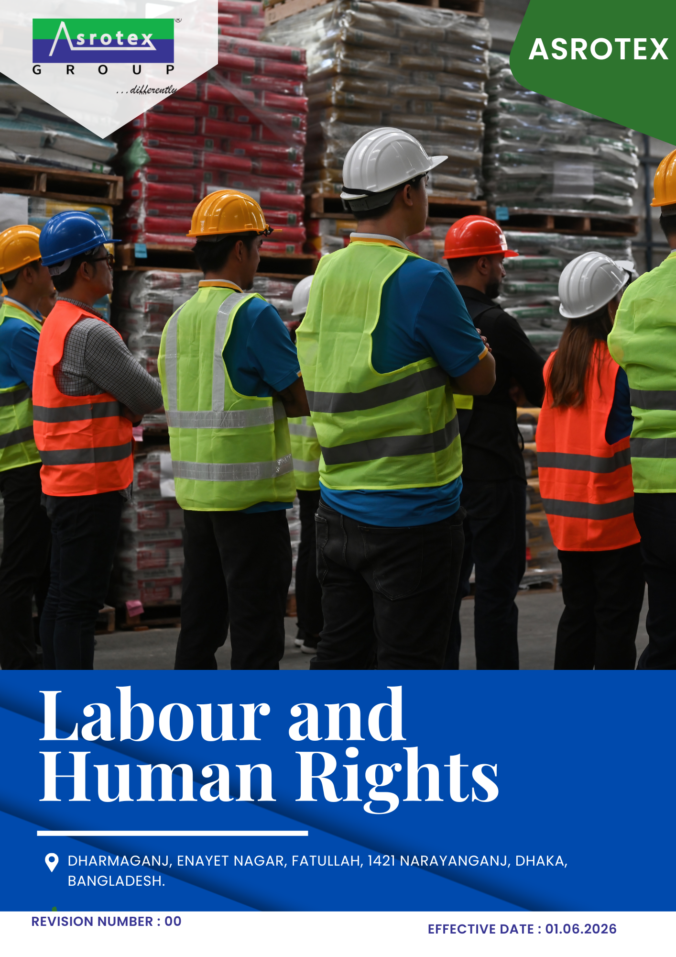

TABLE OF CONTENTS
Asrotex— Labour & Human Rights Policy
01 Preface 3
02 Purpose 3
03 Scope 3
04 Labour & Human Rights Commitments 3
05 Roles & Responsibilities 4
06 Action Areas 5
07 Labour & Human Rights Performance, Monitoring & Reporting 8
08 Review Mechanism & Continual Improvement 8
Annexure A – United Nations Sustainable Development Goals (UNSDGs) 10
Employee Acknowledgment 11

01 Preface
Asrotex is committed to fostering a workplace where every individual is treated with dignity, fairness, and respect. We recognize that protecting labour and human rights is fundamental to sustainable business success and forms an integral part of our corporate values, operational excellence, and long-term growth.
This Labour & Human Rights Policy establishes the framework for promoting fair employment practices, safeguarding the rights and well-being of our workforce, and maintaining a safe, inclusive, and respectful working environment. Through ethical business practices, responsible supply chain management, employee engagement, and continual improvement, Asrotex is committed to upholding internationally recognized labour and human rights principles while creating long-term value for employees, customers, business partners, and the communities in which we operate.

02 Purpose
The purpose of this Labour & Human Rights Policy is to establish a framework for protecting and promoting labour and human rights across Asrotex's operations. The policy aims to foster a safe, fair, inclusive, and respectful workplace by supporting ethical employment practices, protecting the rights and well-being of employees, ensuring compliance with applicable labour and human rights requirements, and driving continual improvement in workplace conditions and responsible business practices.

03 Scope
This Labour & Human Rights Policy applies to all operations and activities carried out at the following operational location of Asrotex:
Sr. No. | Site | Address
1 | Asrotex | Dharmaganj, Enayet Nagar, Fatullah, 1421 Narayanganj, Dhaka, Bangladesh.

This policy covers all manufacturing, warehouse, utility, maintenance, quality, administrative, and support functions under the Company's operational control. It applies to all employees, contract workers, apprentices, temporary workers, contractors, suppliers, service providers, and other business partners performing activities on behalf of Asrotex.

04 Labour & Human Rights Commitments
Asrotex is committed to:
- Upholding internationally recognized labour and human rights principles across all business operations.
- Providing a safe, fair, inclusive, and respectful workplace that promotes the dignity, well-being, and equal treatment of all employees.
- Prohibiting all forms of child labour, forced labour, bonded labour, human trafficking, discrimination, harassment, and any other form of workplace abuse.
- Promoting equal opportunity, diversity, employee engagement, and fair employment practices throughout the employee lifecycle.
- Respecting employees' rights to freedom of association, collective bargaining, and access to effective grievance mechanisms without fear of retaliation.
- Extending labour and human rights expectations to suppliers, contractors, and business partners through responsible supply chain management.
- Monitoring labour and human rights performance and driving continual improvement through regular assessments, employee engagement, and responsible business practices.
Unless otherwise specified, 2023 has been established as the baseline year for measuring labour and human rights performance and tracking progress against the objectives and targets defined in this policy.

05 Roles & Responsibilities
The successful implementation of this Labour & Human Rights Policy requires the commitment and active participation of all personnel at Asrotex. Responsibilities are assigned as follows:
Managing Director
- Provide leadership and strategic direction for labour and human rights management.
- Ensure adequate resources are available to implement this policy and achieve its objectives.
Human Resources (HR) Department
- Implement fair employment practices and oversee employee welfare, engagement, and grievance management.
- Ensure compliance with applicable labour requirements and support the implementation of labour and human rights initiatives.
Department Heads
- Promote a safe, inclusive, and respectful workplace within their respective departments.
- Ensure compliance with this policy and support the achievement of labour and human rights objectives and targets.
Employees
- Comply with the requirements of this policy and treat colleagues, contractors, and other stakeholders with dignity and respect.
- Report any concerns or suspected violations through the established grievance or reporting channels.
Suppliers, Contractors & Business Partners
- Conduct their activities in accordance with Asrotex's labour and human rights requirements.
- Support the Company's commitment to ethical employment practices and respect for human rights throughout the value chain.

06 Action Areas
1 Employees' Safety and Well-being
Objective
To provide a safe, healthy, and supportive workplace by preventing occupational injuries and illnesses, promoting employee well-being, and continually improving workplace health and safety standards.
Initiatives
- Maintain a safe and healthy workplace through effective occupational health and safety practices.
- Conduct regular workplace risk assessments, safety inspections, and emergency preparedness activities.
- Provide appropriate personal protective equipment (PPE), medical facilities, and welfare amenities to employees.
- Promote employee physical and mental well-being through awareness programs, health initiatives, and continuous improvement of workplace conditions.
TARGET
Maintain Zero Workplace Incidents annually.
Conduct 2 workplace health and safety inspections covering 100% of operational areas till year 2030.
Achieve 100% participation in occupational health and safety training annually.
2 Employee Engagement
Objective
To foster an open, inclusive, and collaborative workplace by encouraging employee participation, effective communication, and meaningful engagement across all levels of the organization.
Initiatives
- Promote open communication and constructive dialogue between employees and management.
- Encourage employee participation through engagement programmes, feedback mechanisms, and consultation initiatives.
- Maintain accessible grievance and feedback channels to address employee concerns in a timely and transparent manner.
- Strengthen employee engagement by recognizing contributions and promoting a positive workplace culture.
TARGET
Hold 5 management–labour dialogue sessions till year 2030.
Achieve 90% employee participation in engagement programs by year 2030.
Achieve an employee satisfaction score of 85% in periodic employee engagement surveys by year 2030.
3 Child Labor, Forced Labor, and Human Trafficking
Objective
To uphold fundamental human rights by prohibiting all forms of child labour, forced labour, bonded labour, and human trafficking across Asrotex's operations and supply chain.
Initiatives
- Verify the age and identity of all employees prior to employment through established recruitment procedures.
- Maintain fair and voluntary employment practices, ensuring that no form of forced, bonded, or involuntary labour is permitted.
- Assess suppliers and business partners against labour and human rights requirements as part of responsible supply chain management.
- Raise awareness among employees and suppliers regarding child labour, forced labour, and ethical employment practices.
TARGET
Assess 100% of high-risk suppliers for child labour and forced labour risks by year 2030.
Maintain zero confirmed incidents of child labour, forced labour, bonded labour, or human trafficking across Asrotex's operations annually.
4 Workplace Conditions
Objective
To provide fair, safe, and equitable working conditions that promote employee well-being, dignity, and compliance with applicable labour requirements.
Initiatives
- Provide fair wages, working hours, and employee benefits in accordance with applicable legal and organizational requirements.
- Maintain safe, hygienic, and accessible workplace facilities, including sanitation, drinking water, and welfare amenities.
- Promote work-life balance through responsible workforce planning and effective workload management.
- Regularly review workplace conditions to identify opportunities for improvement and enhance employee well-being.
TARGET
Run annual employee satisfaction surveys on working conditions, reaching an 90% positive satisfaction rate by 2030.
Conduct 3 workplace condition assessments covering 100% of operational areas till year 2030.
5 Discrimination & Harassment
Objective
To foster a diverse, inclusive, and respectful workplace by ensuring equal opportunity and maintaining zero tolerance for discrimination, harassment, bullying, or any form of abusive behaviour.
Initiatives
- Promote equal employment opportunities and fair treatment throughout the employee lifecycle.
- Maintain a workplace free from discrimination, harassment, bullying, and retaliation.
- Provide accessible reporting channels and ensure prompt, fair, and confidential investigation of complaints.
- Conduct awareness programs to promote diversity, inclusion, and respectful workplace behaviour.
TARGET
Raise women's representation in leadership roles to 30% by year 2030.
Provide discrimination, harassment, and diversity awareness training to 100% of employees annually.
Maintain zero confirmed incidents of discrimination, harassment, bullying, or retaliation annually.
6 External Stakeholder Human Rights
Objective
To promote respect for labour and human rights across Asrotex's value chain by engaging suppliers, contractors, business partners, and other stakeholders in responsible and ethical business practices.
Initiatives
- Integrate labour and human rights requirements into supplier selection, evaluation, and business relationships.
- Conduct due diligence and periodic assessments to identify and address labour and human rights risks within the supply chain.
- Encourage suppliers and business partners to implement ethical employment practices and comply with applicable labour standards.
- Collaborate with stakeholders to strengthen awareness, transparency, and continual improvement in labour and human rights performance.
TARGET
Include labour and human rights requirements in 100% of new supplier and contractor agreements by 2030.
Engage at least 80% of key suppliers in labour and human rights awareness or capacity-building initiatives by 2030.

7 Training, Development and Career Growth
Objective
To develop a skilled, competent, and engaged workforce by providing continuous learning, professional development, and equal opportunities for career growth.
Initiatives
- Provide regular training and development programmes to enhance employees' technical, behavioural, and leadership competencies.
- Promote equal access to learning and career advancement opportunities based on merit and performance.
- Identify and develop internal talent through succession planning and capability-building initiatives.
- Encourage continuous learning by supporting professional certifications and skill enhancement programmes.
TARGET
Deliver 20 training hours per employee annually.
Increase internal promotions by 10% by year 2030.
Prepare individual learning and development plans for 100% of eligible employees by year 2030.

07 Labour & Human Rights Performance, Monitoring & Reporting
Asrotex is committed to regularly monitoring and evaluating its labour and human rights performance to ensure the effective implementation of this policy and the achievement of its objectives and targets.
The Company shall:
- Monitor key labour and human rights performance indicators, including employee well-being, workplace safety, diversity and inclusion, training, grievance management, and supply chain human rights performance.
- Maintain accurate records and periodically review performance against established labour and human rights objectives and targets.
- Conduct internal assessments and management reviews to identify opportunities for improvement and implement appropriate corrective and preventive actions.
- Report labour and human rights performance to management and relevant stakeholders, where applicable, to promote transparency, accountability, and continual improvement.

08 Review Mechanism & Continual Improvement
This Labour & Human Rights Policy shall be reviewed biennially, or earlier if required due to changes in applicable legal requirements, business operations, stakeholder expectations, or other relevant factors.
Asrotex shall periodically evaluate the effectiveness of this policy, review progress against its labour and human rights objectives and targets, and implement necessary improvements to strengthen workplace practices and human rights performance. The outcomes of these reviews shall be considered when updating the policy and supporting the Company's commitment to continual improvement.

Rev. No.  00 | Effective From  01.06.2026 | Next Review Date  01.06.2028
Approved By:

Annexure A – United Nations Sustainable Development Goals (UNSDGs)
Asrotex recognizes the importance of integrating internationally accepted labour and human rights principles into its business operations. The commitments, objectives, and initiatives outlined in this policy contribute to the following United Nations Sustainable Development Goals (UNSDGs) :
UN SDG | Key Focus Area | Relevant Policy Sections
SDG 3 – Good Health and Well-being | Occupational health, workplace safety, employee well-being, and healthy working conditions | Employees' Safety & Well-being
SDG 5 – Gender Equality | Equal opportunity, non-discrimination, diversity, inclusion, and prevention of harassment | Discrimination & Harassment
SDG 8 – Decent Work and Economic Growth | Fair employment practices, workplace conditions, employee engagement, freedom of association, and career development | Employee Engagement; Workplace Conditions; Training, Development & Career Growth
SDG 10 – Reduced Inequalities | Equal treatment, diversity, inclusion, and protection of labour and human rights | Labour & Human Rights Commitments; Discrimination & Harassment
SDG 16 – Peace, Justice and Strong Institutions | Ethical labour practices, prohibition of child and forced labour, grievance mechanisms, and responsible governance | Child Labour, Forced Labour & Human Trafficking; Labour & Human Rights Performance, Monitoring & Reporting
SDG 17 – Partnerships for the Goals | Responsible supply chain management and stakeholder collaboration | External Stakeholder Human Rights; Roles & Responsibilities

Employee Acknowledgment
I acknowledge that I have received, read, and understood the Labour & Human Rights Policy of Asrotex. I understand my responsibilities under this policy and agree to comply with its requirements while performing my duties.
I am committed to upholding the principles of fairness, dignity, respect, equal opportunity, workplace safety, and ethical conduct. I further commit to supporting the Company's labour and human rights objectives by promoting an inclusive workplace, respecting the rights of my colleagues and other stakeholders, and reporting any concerns or suspected violations through the established reporting channels.
Name:
Position:
Signature:
Date:

